Charotar University of Sciences and Technology

Charotar Institute of Paramedical Sciences

**A report on Breast cancer awareness campaign October 2018**

The department of Medical Imaging Technology, Charotar Institute of Paramedical Sciences conducted Breast cancer awareness campaign with a theme “Early detection better decision” among female students and staff members of nearby schools in changa, nadiad, anand, damol, mehelav, napad . Breast cancer is presently leading cause of cancer in females, it can be treated only if detected early and we are extremely glad that we took this noble initiative.

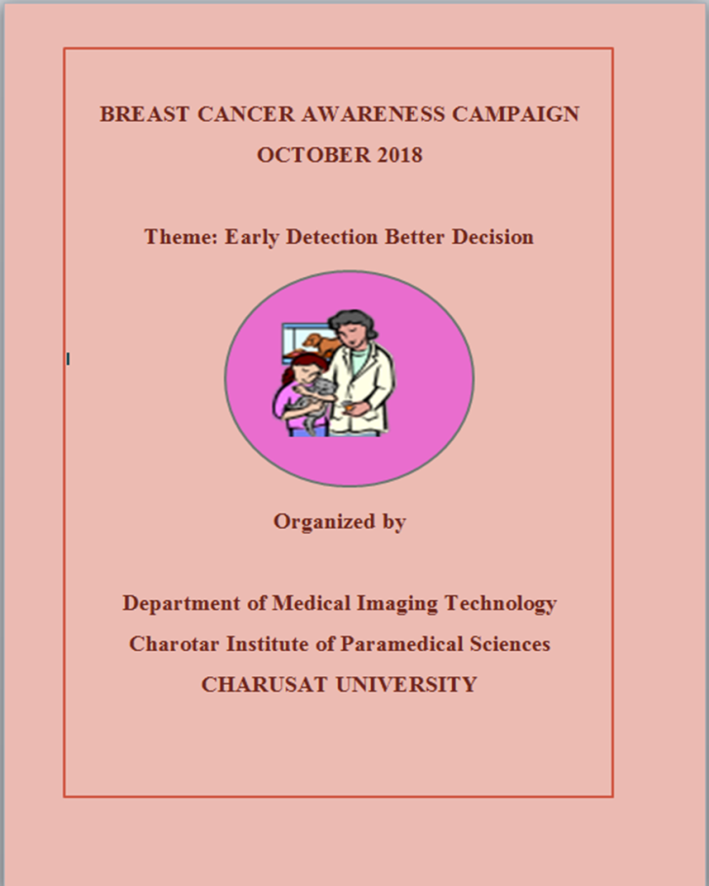

We approached around 10 schools and received permission from the management. Our students in groups from 5th semester BMIT course, staff members went to these schools and given presentations, demonstration on early detection of breast cancer on the days permitted to with timings 10.00am to 12.00pm. We aimed at the topics like Breast cancer and its types, improvement in life style, food habits, imaging modalities available for early screening of breasts.

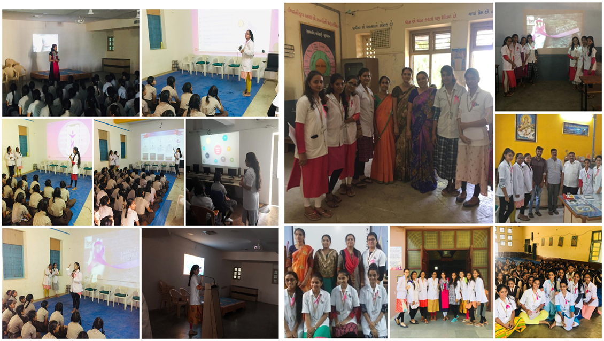

At the end of each session, we took feedback from students which was very good, encouraged our students; however few schools management appreciated our efforts by publishing our sessions in newspapers.

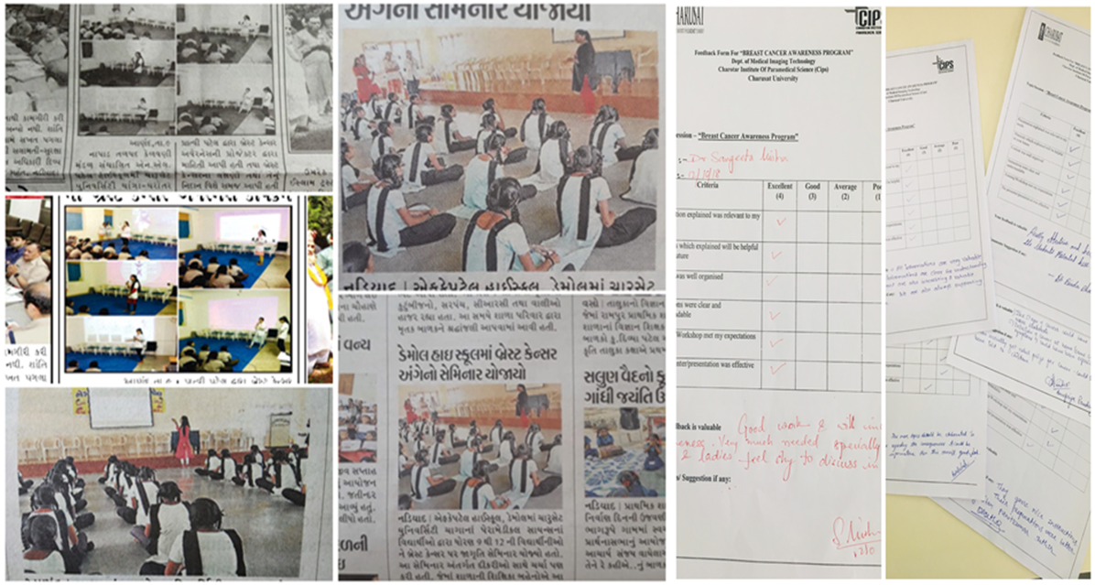

Furthermore, we conducted series of lectures on 5th October by 10am t0 12.00pm at MCA auditorium. The event started with welcome address by Dr. Darhan H patel followed by a brief note on importance of breast cancer awareness by Mrs. Dolly Sharma, The talks were taken by Dr. Rajshri S Patil on early screening of breast cancer from Mahagujarat hospital Nadiad, Dr. Shreya Desai, Paramukhswami Medical College, karamsad and Dr. Sunny Mishra, Charusat Hospital and Research foundation. The program was concluded with grati tude by Mr. Manna Debanath.

